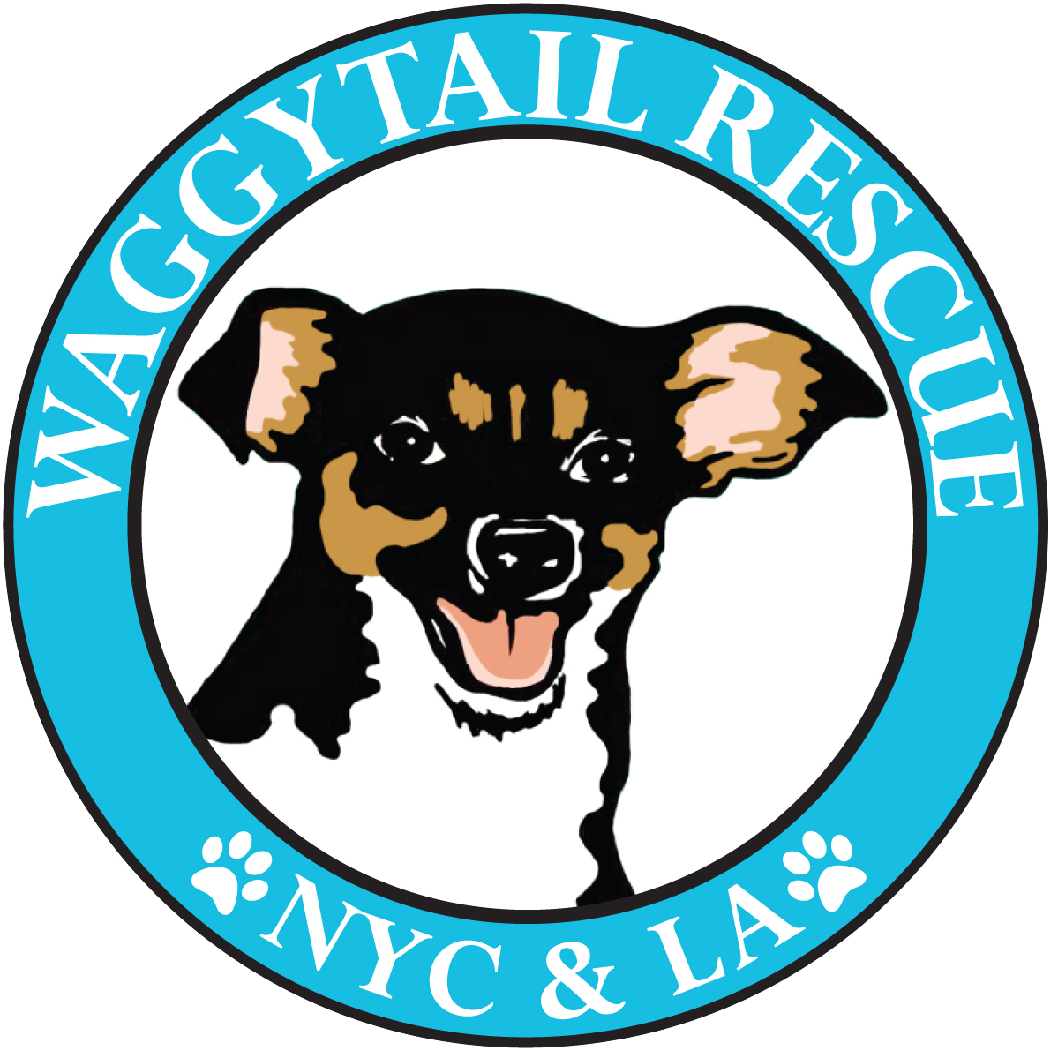
WAGGYTAIL RESCUE
FLIGHT TRANSPORT
APPLICATION

Please return to: waggytailwest@gmail.com

NAME:
AGE:
EMAIL:
CELL PHONE:
EMOTIONAL SUPPORT ANIMAL CERTIFIED:

DATE OF FLIGHT:
AIRLINE & FLIGHT #:
DEPARTURE/ARRIVAL AIRPORTS:
SCHEDULED DEPARTURE TIME:
SCHEDULED ARRIVAL TIME:

LOS ANGELES ADDRESS
Street:
City:
Zip:

NEW YORK ADDRESS
Street:
City:
Zip:

METHOD OF REIMBURSEMENT FOR DOG’S TICKET:
(Check, PayPal or Venmo. Please provide email/mailing address if different than above)

IN LOS ANGELES:
Are you able to take a dog a day (or more) before your flight or do you need airport hand off?

Do you agree that if any unforeseen issues arise with your flight that you ensure the dog makes it safely to your final destination in NYC?

IN NEW YORK:
Are you able to transport the dog to your final destination in NYC for a transfer to a foster or do you need an airport hand off?

How long can you care for a dog in NYC before needing a transfer to a foster (hours, a day, a week etc)?

If you can you foster your pup for more than a day or two, please click here to fill in a foster application and add to it to the end of this document!
PERSONAL REFERENCES:
Please provide the names and contact details of TWO people who can vouch for your ability to be responsible for an animal while traveling!

Name:
Relationship to you:
Cell:

Name:
Relationship to you:
Cell:

- If you are approved a Waggytail representative will work with you via email or phone to iron out logistics and to put you in contact with LA and NYC volunteers/fosters.
- You will need to contact the airline you are flying on in advance to book the dog’s place in carry-on as some airlines restrict the number of animals allowed in cabin.
- We will reimburse the cost of the dog’s plane fare as well as providing the dog, an airline approved dog carrier and a leash/harness.
- The dog’s paperwork (and medication if applicable) will be in the carrier.
- All supplies and paperwork should remain with the dog and be passed on to the foster. They are the property of Waggytail and will be reused for future flights!
- If you fly frequently from LA to NYC and can keep bringing dogs, we love you! Please fill in a new application each time so that we have the correct flight details!

Thanks for applying to be a Waggytail Flight Attendant!
If you have any questions please contact us at waggytailwest@gmail.com!

